|  |
| --- |
| Tutorial 1(Week starting on 28-feb-2022) |

**LOPEZ, FEDERICO ARIEL; METTOLA LA GIGLIA, FRANCO**

|  |
| --- |
| **Objectives**   * Think about the evolution of inequality in the long run * Discuss the relevance of the use of anthropometric information to measure welfare * Interpret basic statistics to describe ideas   **Working materials**   * **Boix, C. & F. Rosenbluth [2014]**; “Bones of Contention: The Political Economy of Height Inequality,” *American Political Science Review*, Vol. 108, No. 1, 1-22 |

**Exercise guide**

The exercises marked with an asterisk (*) are compulsory and must be submitted to the virtual campus **before 12.00 on Wednesday 9th March**. To the mark obtained on the evaluation of this assignment, **0.05 points will be subtracted for each minute late**. Consult the course program with regards to the formalities of the presentation.

1. (*) Explain in just a few words what question are Boix & Rosenbluth [2014] trying to answer and how they attempt to do so. What are the main results?
2. (*) What are, according to the authors, the mechanisms through which the equality that nomad societies held was broken? Describe them in your own words and with examples.
3. (*) What is anthropometry? How do the authors use this tool to answer their question?
4. Explain why the authors use the variation in the individuals’ heights (specifically the coefficient of variation) as a proxy[1] for the distribution of income. What advantages and possible disadvantages does it have?
5. Looking at the article’s tables 2 and 3 that are shown below,  
   a. Explain what every highlighted number means (be detailed in the description). Give a formal definition of what the Coefficient of Variation is.  
   b. When presenting this evidence, the authors hold that a relatively egalitarian modern society (young americans in 1977) have a coefficient of variation of 3,66. Looking at the coefficient of variation of the different societies presented in the tables, which is more egalitarian? What is the main conclusion that can be obtained from comparing these two tables?

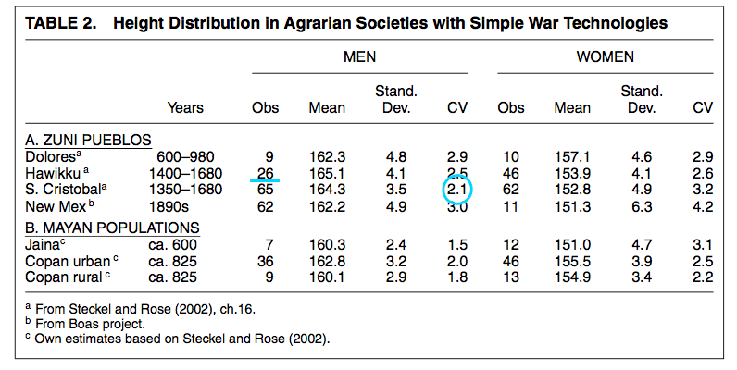

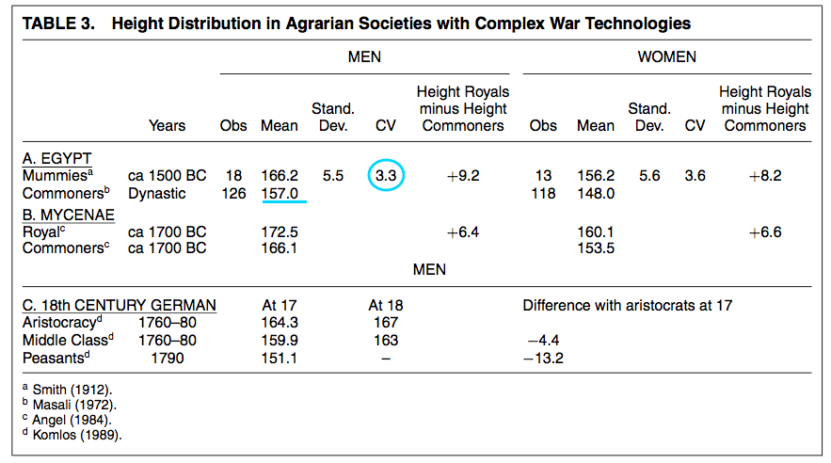

1. The authors are trying to answer whether there is any evidence that, as has been theorized, there was little inequality among the members of pre agrarian societies and how that might have changed along the various stages of development of societies. They attempt to do this using anthropometric data as a proxy for income, given the absence of any archival data on the matter. Using information from the remains of members from various groups and different times, they conclude that it would appear early hunter gatherers did live in less unequal societies that became more so as they gathered newer technologies, transitioned into a more sedentary lifestyle and elites formed that captured significant amounts of wealth because the dispersion of height tended to increase.
2. The paper focuses on two main factors that caused the equality of nomad societies to break which are intertwined. These are: the technological and the geographical. They mention, as an example, how fishers who had boats and better equipment where at an advantage and these could only be used near rivers. So, some technologies couldn’t be properly benefited from in some areas when they started to lead to more productivity and to economies of scale, like some rivers that weren’t wide enough for boats or nets or lands that were not fertile enough (those aren’t examples in the paper). That is what the paper suggests was a driving force behind furthering inequality mostly between societies, while they also note that within societies, they were probably made unequal through advancements in military technology which increased the cost of defending their ever-more sedentary lives from bandits and led to a rent-seeking class who defended them when there was no longer incentive or any possible benefit to wage war personally.
3. Anthropometrics is the process by which one can obtain measurements of the human figure using various types of inferences from the properties of our bodies like, as is relevant for this case, the sizes of bones to obtain the height of an individual. The authors take data on height obtained anthropometrically from very old remains to make assumptions about the people to whom those bones belonged and specifically to use as proxy for income as it is a fact that better nutrition, which could serve as a rudimentary indicator of income inequality if some people had more food than others, is likely to lead to increased height.
4. The authors take the coefficient of variation for the heights of ancient peoples as a proxy because it can be reasoned that, in an unequal society, more affluent members would have had access to better nutrition and therefore the chance to grow taller, while lesser endowed people should therefore be shorter. The coefficient of variation in particular is useful because they are comparing various datasets between each other so having the ratio of the standard deviation of the sets and the average lets us see how unequal they are in relation to one another. The advantage is that it lets us easily compare the various populations’ heights to have an estimation of income which would otherwise be impossible to obtain and there probably aren’t many other accurate ways to obtain income data on ancient humans. Though using the coefficient of variation (CV) could mean little if the population size is too small like in the cases for societies for which there weren’t many bones found such as for the Mayans or there might be some type bias because only certain groups were buried in such manner as to be conserved like the upper strata, and, more significantly, that only adults are included in the population yet it would make sense for those in the lower ends of the distribution, with lesser income/worse nutrition, to not make it past 18. The authors recognize this fault but say that most other measures of inequality also don’t correct for this issue, so it doesn’t matter. They also mention that, just using the CV, they can’t conclude the direction of causality but that isn’t relevant since the only important thing is that there exists *a* causal relationship and that the two variables are correlated. Another issue deemed irrelevant by the authors is that height is determined both by nutrition and also genetics so it could be that a genetic predisposition for tallness of some group coincides with their position in society and disturbs the results, but they find the ethnicities of the populations to be similar enough over time.
5. A. The number 26 under Obs, we believe, is the number of corpses contained in the dataset analyzed for the Hawikku site in New Mexico. This seems odd given that the source they report (Steckel and Rose) lists 187 total bodies found and 146 that are older than 5 (Figure 1), which would mean that, since the paper says it looks just at adults up from 18 years old, 120 of the original observations reported in Steckel and Rose (2002) are between the ages of 5 and 18. That just isn’t possible because Steckel and Rose’s source for their data, Stodder (1994), who reports on the remains dug up in 1914 at the Hawikku site, lists the actual corpses in the set by age and they are much more evenly distributed, there being 72 bodies in the set that are older than 20. [What Steckel and Rose actually say about stature we could not see because it was behind a paywall] So anyways we aren’t quite so sure where the 26 comes from or what it actually means.

Figure 2 Stodder, A 1994 Bioarchaeological Investigations of Protohistoric Pueblo Health and Demography. In the Wake of Contact: Biological Responses to Conquest. C.S. Larsen and G.R. Milner, eds. New York: Wiley-Liss. Pp. 97-107 (P. 100)

Figure 1 Steckel, R.H., J.C., Rose, The Backbone of History: Health and Nutrition in the Western Hemisphere. Cambridge University Press, 2002. (p 78)

Next, the number 2.1 under CV is the result of taking, first, out of the (arguably) 65 observations in San Cristobal, their standard deviation, that is, the estimation of how much the heights in the dataset deviate from the mean of the heights. This shows us somewhat how far apart the tallest and shortest are from each other in the society and therefore how unequal it is. With the standard deviation, they divide it by the mean to get a number that can be compared with the same results taken from the other datasets and from which we can conclude that a bigger number tells that that society is more spread out from the mean than another smaller one. That number is the coefficient of variation. In this case, San Cristobal reports the lowest CV in the A section so it would suggest it was the most equal in heights of the four.

Then, we have again a CV, this time 3.3 and taken from mummies of ancient Egypt. In this table there isn’t much to compare it to other than the female results, who are more unequal. What we can compare is the other highlight, the mean of the heights of commoners which is just the sum of the individual observations divided by the number of observations. Itself it shows us that indeed commoners were quite shorter than royalty (who were the ones mummified).

B. It would seem that young Americans are more unequal than the societies analysed, because the CV indicates the results are less spread out from the mean in the Zuni Pueblo and Mayan societies than 3.66. So, either the Zuni Pueblos and the Mayans are more egalitarian than young Americans or Boix and Rosenbluth’s data is bad.

Comparing these two tables, we could say, although not with too high a degree of certainty, that only by the time of modern militaristic states were societies considerably unequal taking the difference in the mean for peasants and royals while previous tribes remained quite equal among them.

1. A ‘proxy’ is a variable that isn’t relevant on its own but serves as a replacement for a variable that is not observable or hard to measure.